Here's What It's Like To Drive A Nutty Vintage Studebaker
Aaron Vick Starnes
1/23/15 5:35pm
Filed to: STUDEBAKER
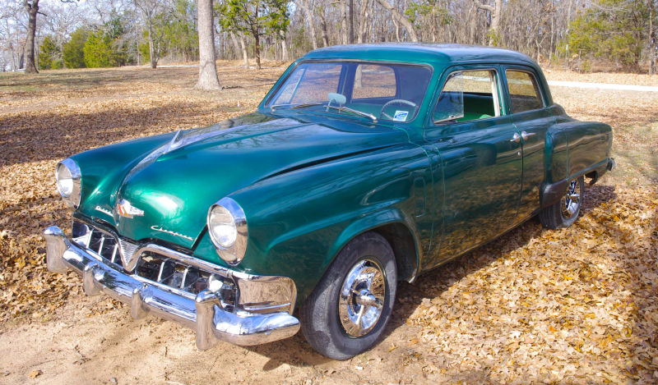
Last Friday I was lucky enough to go for a spin in a mid-century automotive oddity, a 1952 Studebaker Champion named Kermit.
The '52 cars are somewhat less collectible than "bullet-nose" body style that preceded them. They represent a transitional period in the Champion's line, and the only year of this particular body. The Champion had a 19 year run between '39 and '58. The short list of unique features on this car include cool wrap-around rear glass.
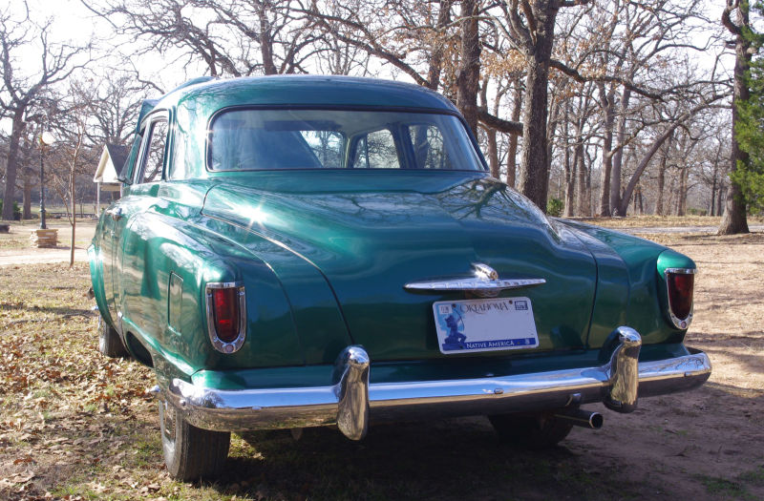

It has a parking brake that comes through the dash just below the gauges.
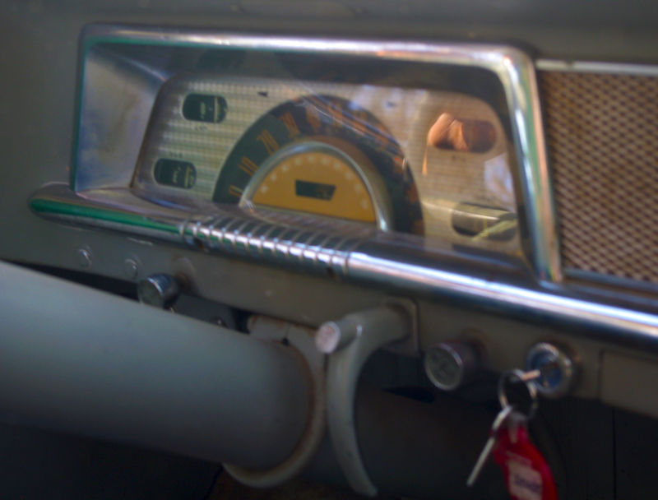
It has fresh air vents in the fenders that are controlled by little levers mounted under the dash.
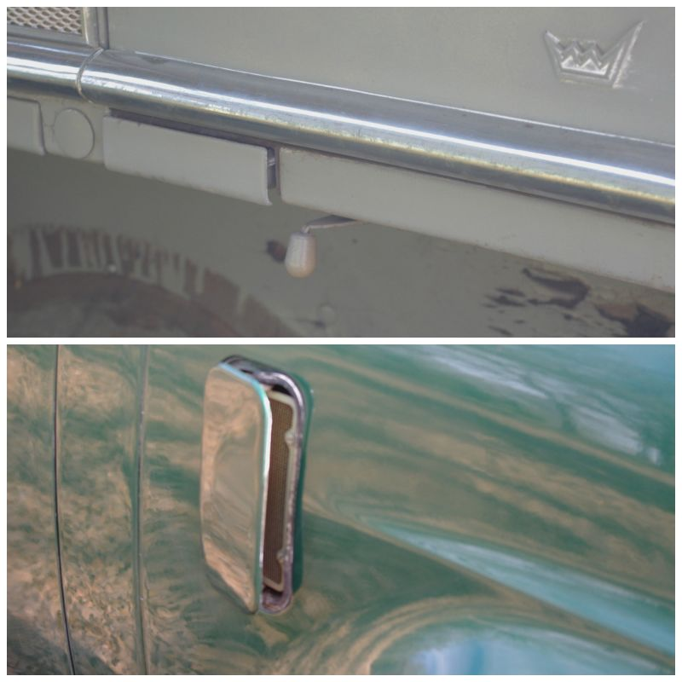

And what may be the most exciting feature of the car, a pair suicide rear doors
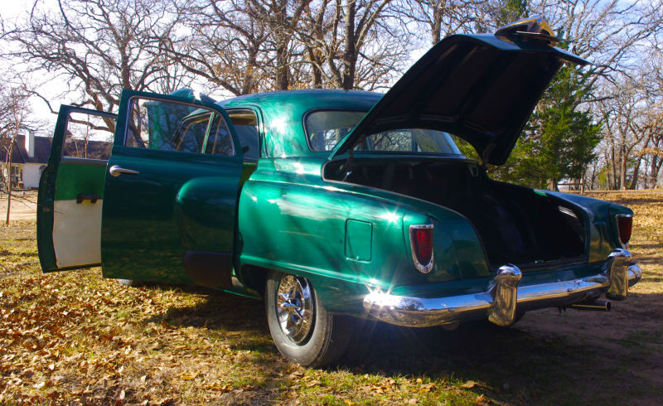
After getting to know the car a little bit, crawling around inside like an over-caffeinated kid, and familiarizing myself with all the levers, knobs and switches, Mr. S said "Let's go for a ride." I was already smitten with the little green machine and agreed heartily.
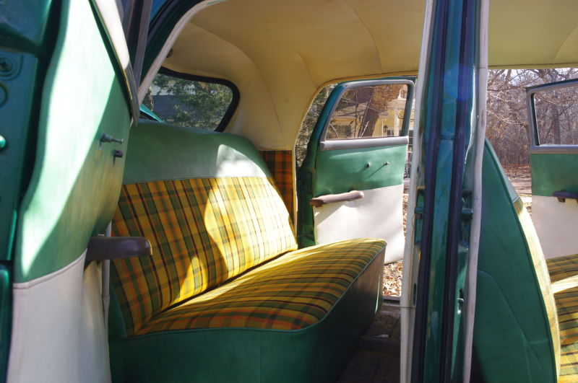
Although the morning air was brisk, which generally causes hard starting in older cars, the plucky little Stude cranked right up without hesitation and settled into a pleasantly smooth idle. Interesting note, on these cars the starter button is on the floor board adjacent to the dimmer switch. To start the engine you turn the key on and press the clutch pedal all the way to the floor. This mashes down on the starter button thus turning then engine over.
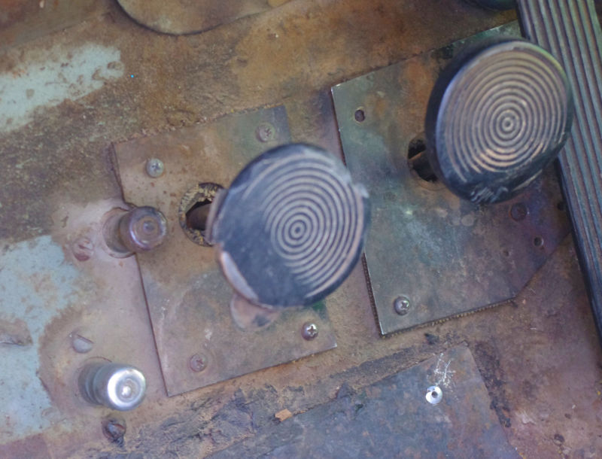
The flathead in-line six cylinder was good for 85 hp back in '52, and felt like it could still deliver on that claim today. This is pitiable by today's standards but it does move this light weight car along without trouble.
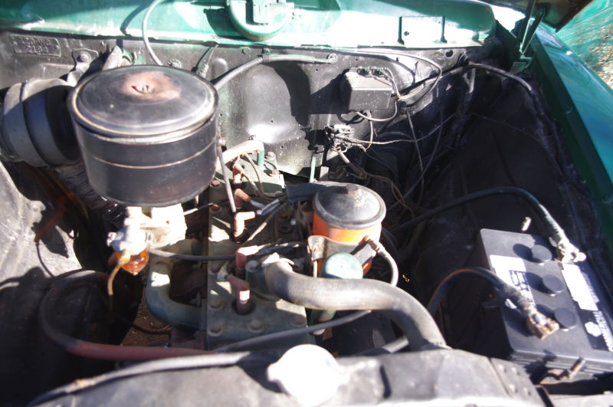
I eagerly piled in through the passenger side door onto the dashing yellow plaid interior. For a small car it feels pretty spacious inside. I was able to stretch my legs and enjoy the little cruise around the block. "Block" in this sense is figurative, Mr. S lives in a pretty rural area. So we tooled down the vacant dirt roads leaving a little cloud of dust in our wake.
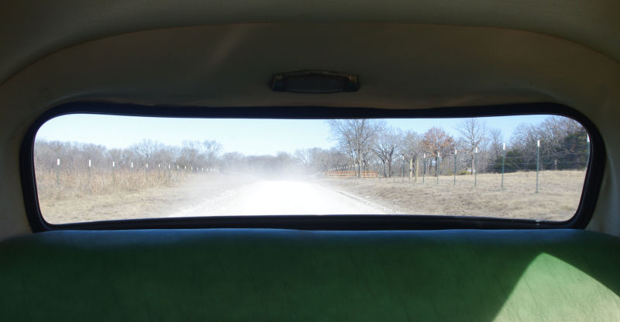
Taking a ride in some un-restored vintage iron like this is something every car guy should make a priority . It's a little like that feeling you get when you watch an old movie. You begin to gain a sense of how different things were only a half-century ago. When people said stuff like "Hey, what's the big idea?" and everything good was "swell".
I'm not given to a line of "those-were- the-good-old-days" thinking or anything, but I appreciate old cars for what they are. They're stepping stones in the path to the cars we drive today. It's like stepping into a time capsule. It's easy to imagine people going about their daily lives using these cars, when they were common place rather than unique. A lot of the amenities are antiquated by today's standards, to the point of absurdity in some cases, but I love crawling into an unrestored, non-customized car and basking in the odd glow of all the anachronisms.
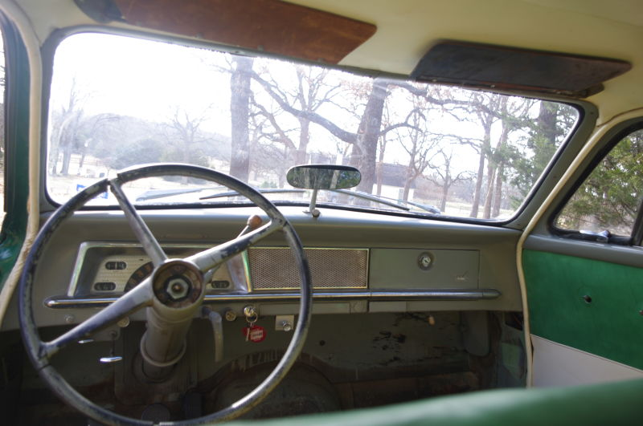
Mr. S asked me if I wanted to take a turn at the wheel and I jumped at the opportunity to slide across the bench seat into the driver's position. I pulled the shifter back and down for first gear, leaned into the gas and let out the clutch. The car was away with a little scratch from the back tires against the gravel road.
Shifting gears in an old car can take some getting used to. Of course there were floor shifted cars like there are today, but there was another configuration that was pretty common. The "three on the tree" set up.
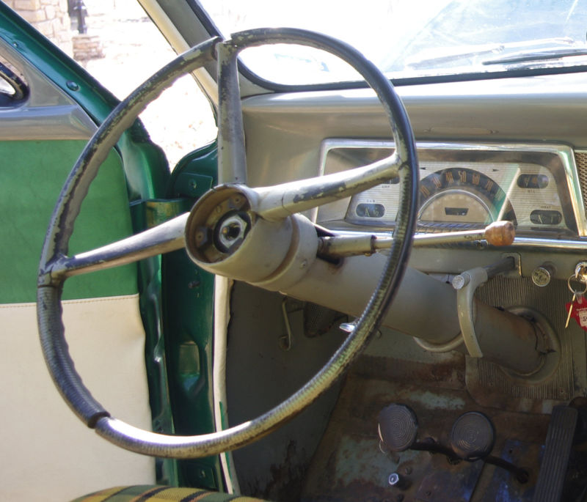
This referred to a three speed manual with a shifter mounted on the steering column. The shift pattern is much the same as it would be on the floor but on a different axis. Up and down rather than back to front and forward and back rather than side to side. This car came with overdrive which gives it a little more legs on the interstate. Once in top gear the driver would engage overdrive by pulling out a knob labeled "OD" on the dash.
Standards for the way a car should feel have changed. Today's cars need to be tight and reassure drivers with a little resistance here and there. Judging by this car and my old Ford of a similar vintage, that didn't seem to be in vogue 60 years ago. These cars are loose both from wear and by design.
There's a sort of willy-nilly feel to the steering. I like to think that it speaks to the hopeful, faith-filled, forward-looking attitude of post-war Americans. Squinting as they looked ahead to the bright shining future, not knowing what it would hold, but believing that everything that lay ahead was good and right.Of course that's romantic nonsense, but it helps to have a little faith when driving one of these.
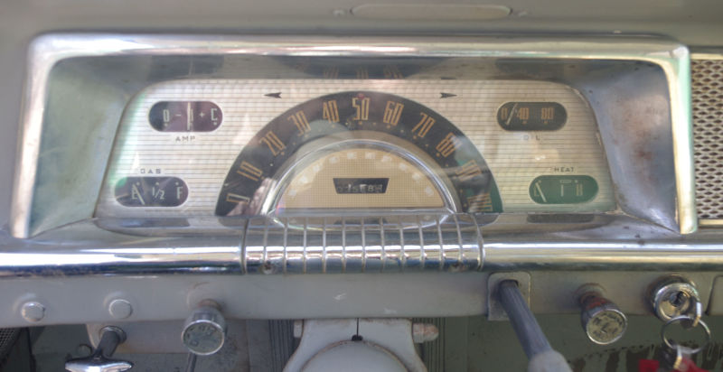
There's about an inch or so of slop in the steering wheel (which is better than in my Ford). This can be dialed down a little by adjustments in the steering box for a more modern feel. The brakes are on the mushy side relative to their modern-day counterparts but they are functional.
The accelerator pedal, like the steering, requires some faith. It's there, you can see it and feel it with your foot, but don't expect a lot of feedback. Drivers just have to believe if they press it down the engine will rev. In the little car's defense I was wearing some thick-soled boots that probably insulated me from pedal feel.
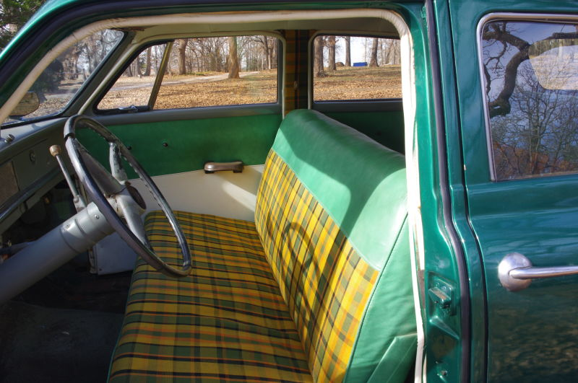
So how was the drive? It was hysterical. I laughed like the entire time I was behind the wheel. Old cars like this one evoke a giddy feeling in me partly because of their absurdity and partly because of the uniqueness of the driving experience. I probably only touched 40 mph but I had a blast. I just eased the car along and stirred through the gears on the way back to Mr. S's. Full disclosure, I did miss a down shift to second and lost momentum while rolling back into the driveway.
This is a car build during an era when cars were sold on style first, before wind-tunnel testing lead to homogenizing the profile of most cars. When their design was dictated by soul rather science. This particular car was someone's dream, the former owner was attempting a restoration in his garage before he passed away. It's not a professionally built show car but rather a good honest driver. It's a small car that's big on character. If you want a Champion of your own a quick search on craigslist will probably yield one or, for the right price, this one could be yours
2 years ago Aaron Vick Starnes quit his well paying bank job to pursue inevitable poverty as an automotive writer. He has experience in automotive restoration, and works at a shop restoring and customizing cars. He also is a grad student in journalism. Follow him on Twitter @AaronVStarnes and check out his blog.
BONUS PICS!
