​This 3-Wheeled Murder Machine Is A Blast To Ride
Aaron Vick Starnes
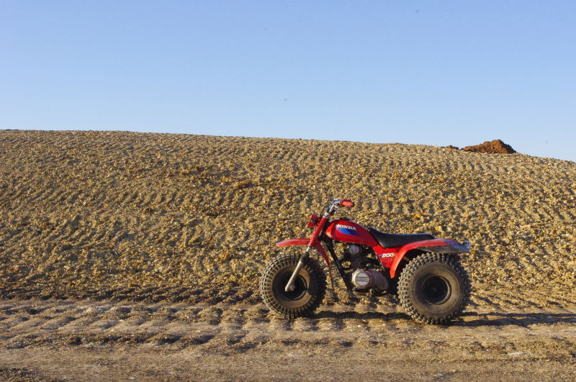
Some folks get their kicks by jumping out of planes. Others like to keep dangerous animals like cobras and tigers in their backyards. There is a thrill in keeping something around that can poison or maul a person to death. Stephen F. collects a different sort of hazard; he gathers 3-wheelers.
Stephen is a firefighter from Texas who volunteered his 1985 Honda ATC 200S for a photoshoot and write-up. He is a thrill seeker through and through, particularly if things could do him bodily harm. Stephen began collecting 3-wheelers from the 80's about two years ago.
Three wheelers, or ATCs, were taken out of production two decades ago because their inherently tippy design had the funny little tick of paralyzing or murdering their operators. It seems the American public frowned upon little Timmy or Billy getting a shiny new 3-wheeler for Christmas and then having their tender little neck pile-driven into terra firma at speed permanently crippling them just in time for the new year.
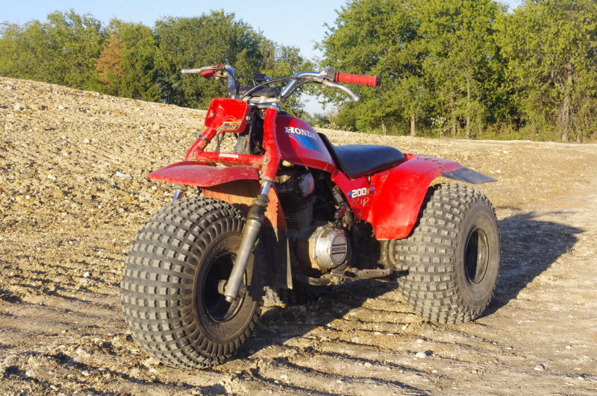
Why ride a 30 year old machine with a murderous reputation? Stephen says it is "because things that are more dangerous are more fun, it's been like that ever since I was a kid. All the fun things were off limits."
It is not hard to find information that will paint a grim picture of these toys as dangerous murder machines. Practically any ATV forum has at least one thread debating the legality and danger of trikes. The polarizing argument between the don't-tread-on-me types who are still angry about the government ban on 3-wheeler and those who see the inherent flaws in their design rages on today.
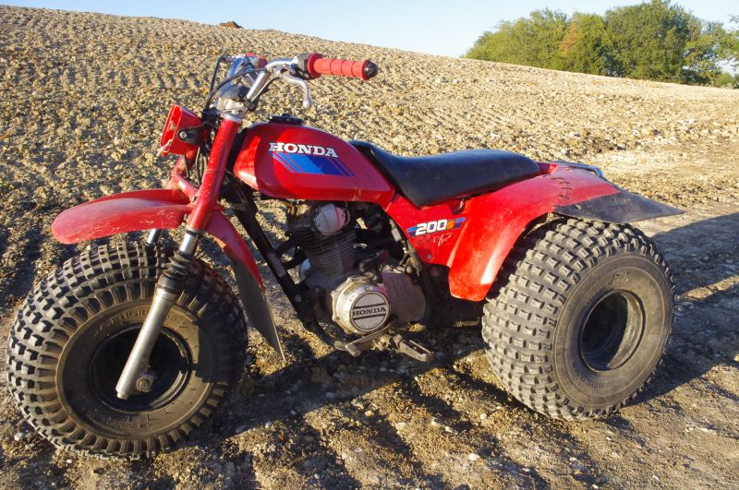
When you buy one you have to understand the potential danger in riding them. They are twitchy and tricky, they are also just about the most fun I have ever had riding an off road toy. For outrageous excitement, and balls out adrenaline rush they are second to none. Each time I got close to the ragged edge of sane operating speed there is a little voice in the back of my mind starts shouting reminders of how horribly bad the ride could go, and I found myself backing off the throttle.
I won't dwell on the topic of the ban but if you want to read about that have a look at this article from People Magazine.
On with the ride
A swift yank on the pull start and a simultaneous crack of the thumb throttle gets the party started. This machine still sits and idles beautifully even after three decades. There is no clutch control. It has a semi-automatic transmission and, oddly, neutral is all the way at the top, and you click down with your left toe to up shift. This makes for some pretty startling accidental downshifts while you are getting used to the transmission.
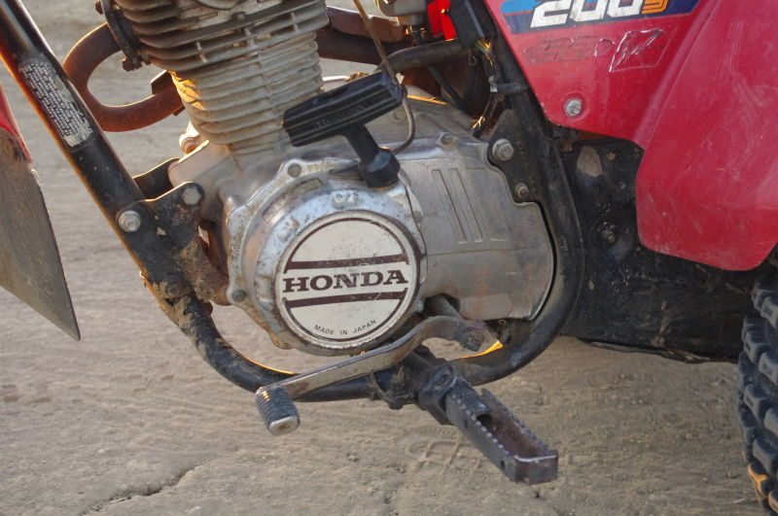
Handling
These things refuse to turn at speed, they have to be gently persuaded into an easy arc. In fact they don't really turn at slow speeds. From a standstill you turn the front wheel to one side, give it some throttle and watch the knobby front tire push the dirt along until it gets rolling and then the turn begins. The proficient rider learns to rock the trike up on the front and outside rear tires to turn tighter circles.
12
ATCs can clobber riders almost without warning due to their big bouncy tires. If you hit the right series of bumps at speed the trike is likely to jump on top of you and smash your guts out. Many models relied on these big bouncy tires as their soul means of suspension. This is like riding 3 rubber balls, once compressed they must rebound, often violently.
Trikes ask their riders to go against natural instincts. Imagine climbing a hill at full throttle and things go all tippy. A rider's instinct is to put their foot down to stabilize things but in this case there is a big knobby tire waiting to grind the back of their calf.
All the terror aside these things are hysterically fun to ride. They are wheelie monsters that can drift. The experience is unlike anything else.
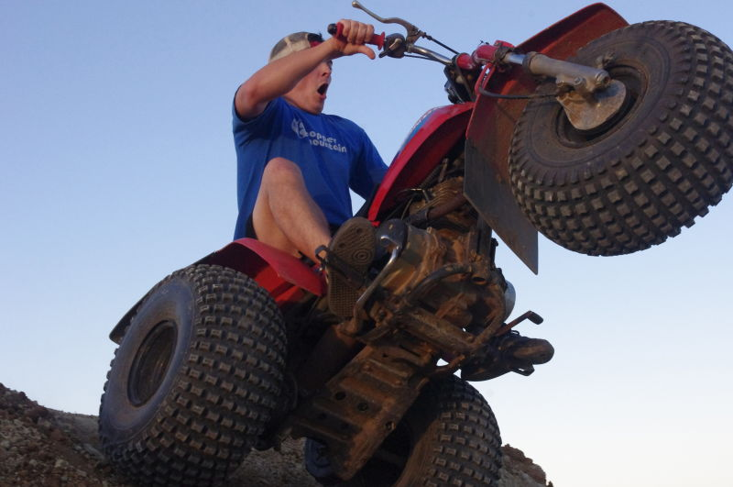3
Acceleration/Power
The throttle takes some getting used to. These trikes have slide type carburetors that respond better to gentle persuasion rather than just whacking it open. A little time in the saddle and you can start to predict when the 200cc single cylinder enters its powerband. The rpm climbs in a deliberate but hasty way from idle and then really take off. It is not a violent action but it certainly will get a rider's attention.
456
Pretty soon you are taking advantage of the engine's predictability and the solid rear axle for drifty sideways action, donuts and wheelies. Going sideways on a trike is a lesson in bravery. You have to suspend your apprehension of being thrown and hammer the gas and when you feel the engine come into its power band crank the bars over. Voila a drift, or more donuts than Shipley's .
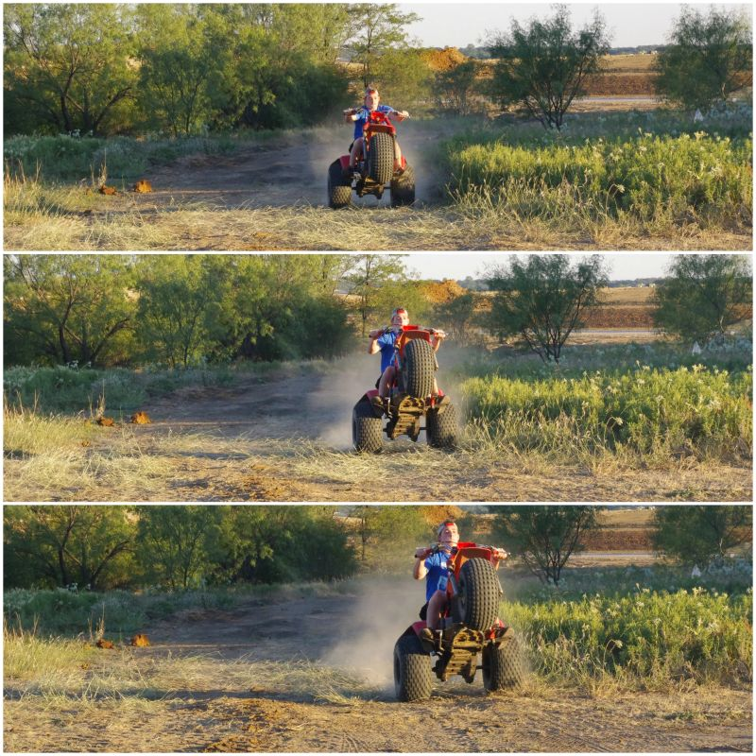
Just like that tiger you've got caged in your backyard, it's not a question of if that terrifying man eater is going to bite you, it's a matter of when and how hard.
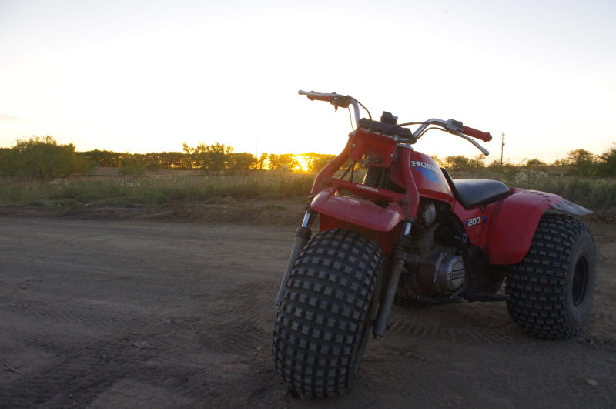
2 years ago Aaron Vick Starnes quit his well paying bank job to pursue inevitable poverty as an automotive writer. He has experience in automotive restoration, and works at a shop restoring and customizing cars. He also is a grad student in journalism. Follow him on Twitter @AaronVStarnes and check out his blog.

